Elizabeth Nofs
COmputers Are Us
Prepared for Our CLient: Deeter Poohbah
DeeterP aok123
Computers Are Us
Bug Report: Prepared for Charlotte’s Web SIte

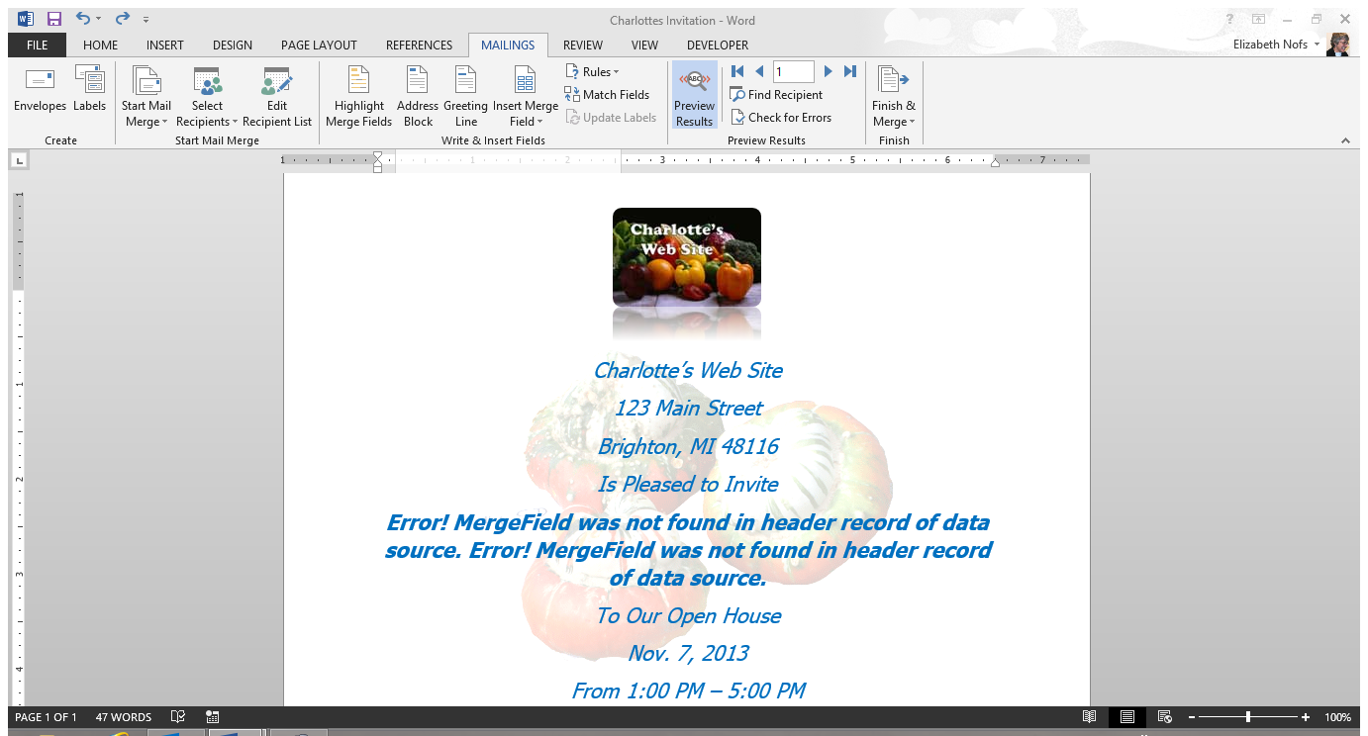

Name: Click here to enter text. |  | Location:
Computer Name: |  | Date: Click here to enter a date.
Operating System: | Choose an item.
Applications open at the time of the incident:
Choose an item. | Choose an item. | Choose an item.
Severity of the Problem: | Choose an item.
Presenting Issue:
Bug Report

