Charlotte's Web Site
From the farm to your table: that’s fresh!

Fresh Fruits
Apples
Avocados
Kiwis
Pears
Fresh Vegetables
Chives
Tomatoes
123 Main Street
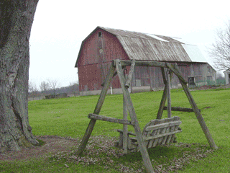
Brighton MI 48116
Friday, August 20, 2010

Dear Sir,

Thank you for your recent order from Charlotte's Website.

Sincerely,

Elizabeth

