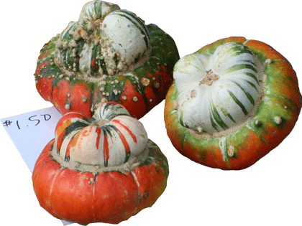
Charlotte’s Web Site
123 Main Street
Brighton, MI 48116
Is Pleased to Invite
«First_Name» «Last_Name»
To Our Open House
Nov. 7, 2013
From 1:00 PM – 5:00 PM

