The Circus is Coming to Town!
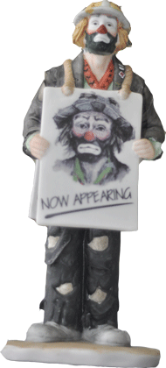 | 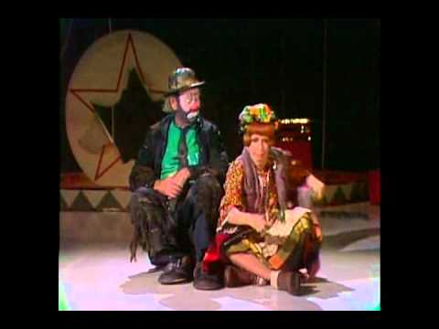Clowns, Elephants and Performers  MyTown Plaza  November 7, 2013  Sponsored by Charlotte’s Web Site

